No exceptions! You must show all work and/or explain your answers to receive full credit.
( 10 points- 2 point per question)
Please Note : It is recommended that you print and write out your answers. Scan/take a photo and upload to the drop-box in Unit 4, Lesson 8 Slide 3. (You may use extra paper as needed – make sure it is uploaded as well.)
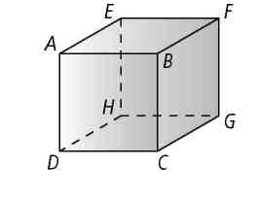
Lesson 3-1. Use the cube to name the following.

- all lines that are parallel to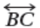
- all lines that are intersect to
- all lines that are skew to

Lesson 3-2. Find the measures of angle 1 and angle 2. State the theorem or postulate that justifies your answer.
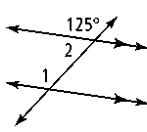
4.

Lesson 3-3. Find the value of x for which a || b.
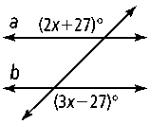
5.

Lesson 3-4. Write a proof.

6. Given: 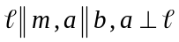
Prove: 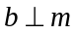

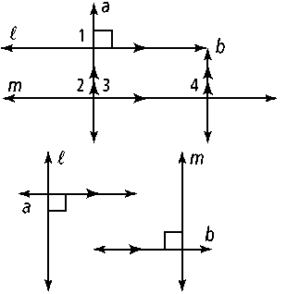

Lesson 3-5. Find the value of x and y.

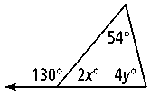
7.

Lesson 3-6. Construct a rectangle with sides b and a.

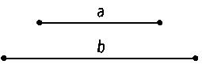
8.

Lesson 3-7. Write an equation in point-slope form of the line that contains the given points.

9. A(4, 2), B(6, −3)

Lesson 3-8. Write an equation for the line perpendicular to the given line through the given point.

10. 